**Date: 31st July 2021**

**Notice**

It is our pleasure to inform all Faculty members and students that M.K. College of Education will be conducting a Value-Added Course on "Developing Soft Skills for Professional Success" Faculty members and students interested in joining the course are requested to contact the course coordinator.

**Course details**

Title: Developing Soft Skills for Professional Success

Duration: 30 Hours

Commencement Date: 16th August 2021

Mode: Online

**Developing Soft Skills for Professional Success**

**Course Duration:** 30 Hours

**Program Learning Outcome**

The course aims to enable the participants to develop a comprehensive set of soft skills, empowering them to communicate effectively, collaborate seamlessly, adapt to diverse workplace challenges, and contribute positively to professional environments.

**Course Learning Outcomes:**

Learners will be able to

1. Define soft skills and recognize their crucial role in personal and professional success
2. Demonstrate effective verbal and non-verbal communication
3. Identify strategies for building and leading effective teams
4. Develop effective time management strategies.
5. Cultivate empathy and social awareness in professional interactions

**Unit 1: Introduction to Soft Skills (4 hours)**

**Concept and importance of soft skills in workplace**

Role of soft skills in personal and professional success, Orientation to key soft skills: communication, teamwork, adaptability, and interpersonal skills, Self-assessment of current soft skill strengths and areas for improvement.

**Unit 2: Effective Communication (6 hours)**

Definitions, Scope and Importance of Communication, Types of Communication, Levels of Communication, Effective Listening, Communication Process, Barriers to Effective Communication, Overcoming Communication Barriers

**Unit 3: Decision Making and Negotiation: (5 hours)**

Introduction to Decision Making, Steps for Decision Making, Decision Making Techniques, Negotiation Fundamentals, Negotiation Styles, Major Negotiation Concepts

**Unit 4: Employment Communication (4 hours)**

Introduction, Resume, Curriculum Vitae, Scannable Resume, Developing an Impressive Resume, Formats of Resume, Job Application or Cover Letter

**Unit 5: Time Management and Organizational Skills (6 hours)**

Importance of Time Management, Key Factors of Time Management, Effective Time Management, Techniques to Practice To Master Your Own Time

**Unit 6: Emotional Intelligence (5 hours)**

Meaning and Definition, Need for Emotional Intelligence, Intelligence Quotient versus Emotional Intelligence Quotient, Components of Emotional Intelligence, Competencies of Emotional Intelligence, Skills to Develop Emotional Intelligence

**Evaluation Criteria**

At the end of the course, a test will be conducted for evaluation. The test will consist of 25 objective type questions carrying 2 marks for each question. It is compulsory to score 40% marks in the final test to earn a certificate of successfully completing the course.

**Mode of Classes**

The Course will be conducted through online mode. Google Meet platform will be used to deliver the content.

**Cost**

The course is free of cost

**Important dates**

|  |  |
| --- | --- |
| Registration starts | 2nd August 2021 |
| Registration ends | 14th August 2021 |
| Start of Course | 16th August 2021 |
| Final test | 4th October 2021 |

**Brochure**

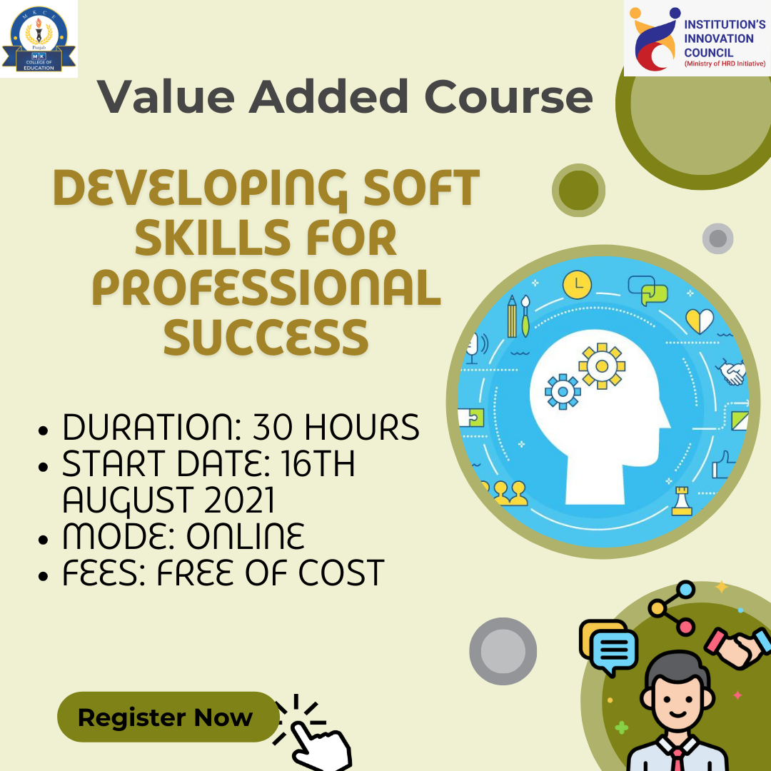

**Classes**

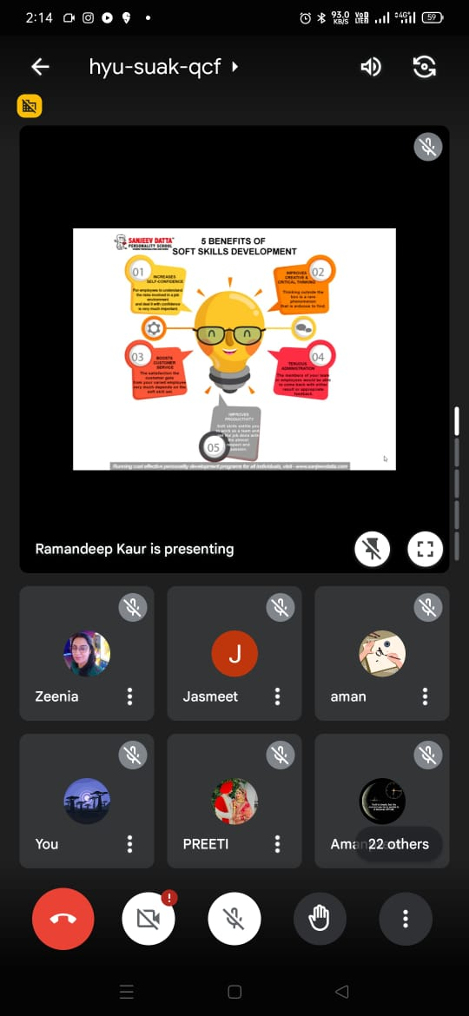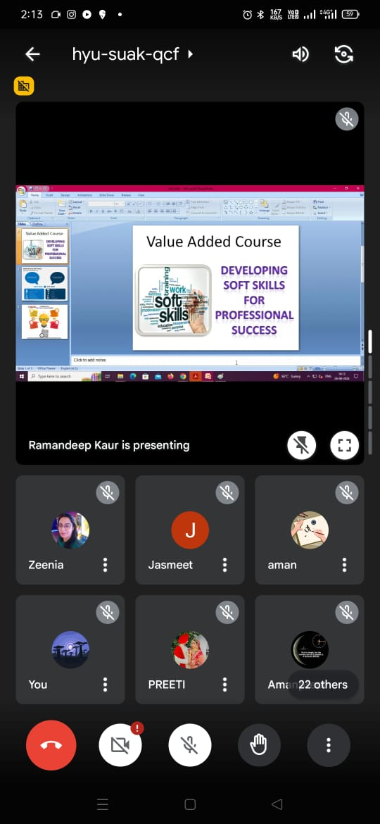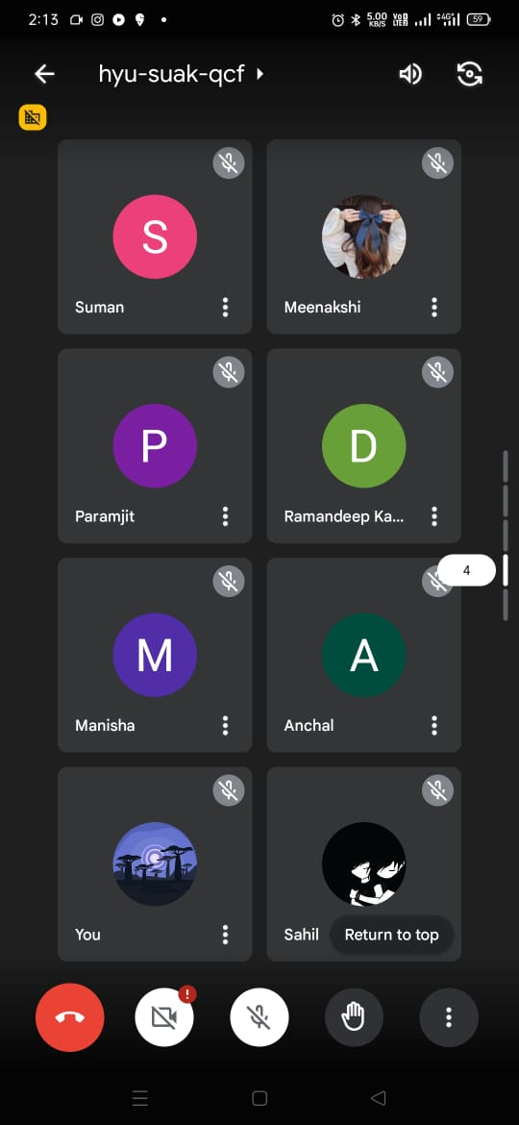

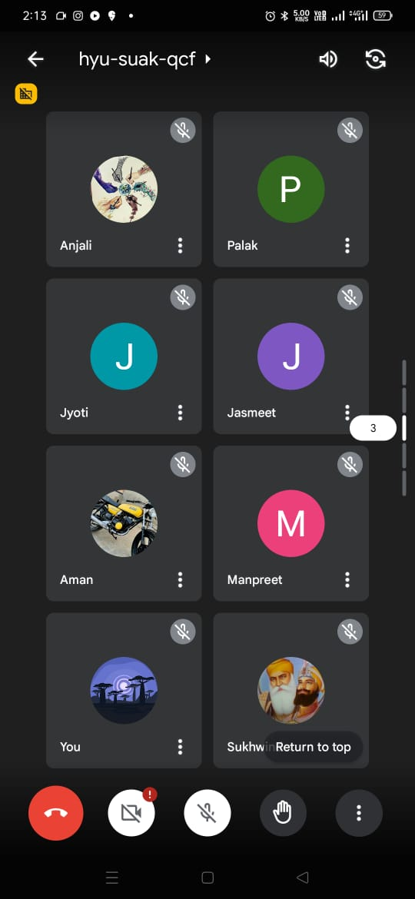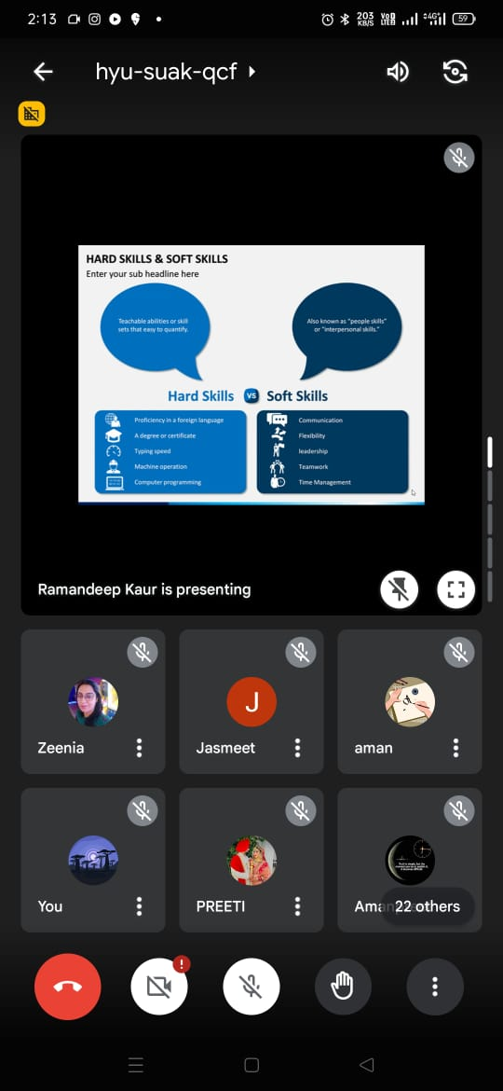

**List of Students enrolled in Value Added Course “Developing Soft Skills for Professional Success”**

|  |  |  |  |
| --- | --- | --- | --- |
| **S.No.** | **Name of the Student** | **Programme** | **Year** |
| 1 | Ranjna Devi | B.Ed. | 2021 |
| 2 | Nayala Arora | B.Ed. | 2021 |
| 3 | S V Siresha Ramella | B.Ed. | 2021 |
| 4 | Lal Singh | B.Ed. | 2021 |
| 5 | Monika | B.Ed. | 2021 |
| 6 | Dimple | B.Ed. | 2021 |
| 7 | Sheena | B.Ed. | 2021 |
| 8 | Bhawna | B.Ed. | 2021 |
| 9 | Priyanka Kumari | B.Ed. | 2021 |
| 10 | Mandeep | B.Ed. | 2021 |
| 11 | Prabhleen Kaur | B.Ed. | 2021 |
| 12 | Shruti | B.Ed. | 2021 |
| 13 | Jaswinder Kaur | B.Ed. | 2021 |
| 14 | Harleen kaur | B.Ed. | 2021 |
| 15 | Harsh | B.Ed. | 2021 |
| 16 | Raj Pal | D.El.Ed. | 2021 |
| 17 | Ajnesh Kumar | D.El.Ed. | 2021 |
| 18 | Harmeet Kaur | D.El.Ed. | 2021 |
| 19 | Anmol Brar | D.El.Ed. | 2021 |
| 20 | Silochana Devi | D.El.Ed. | 2021 |
| 21 | Monika Rani | D.El.Ed. | 2021 |
| 22 | Renu Bala | D.El.Ed. | 2021 |
| 23 | Sudhir Kumar | D.El.Ed. | 2021 |
| 24 | Sonu Kantiwal | D.El.Ed. | 2021 |
| 25 | Amandeep Kaur | D.El.Ed. | 2021 |
| 26 | Sanna | D.El.Ed. | 2021 |
| 27 | Nikita | D.El.Ed. | 2021 |
| 28 | Manish Kumar | D.El.Ed. | 2021 |
| 29 | Surinder Kumar | D.El.Ed. | 2021 |

**Sample course completion certificates**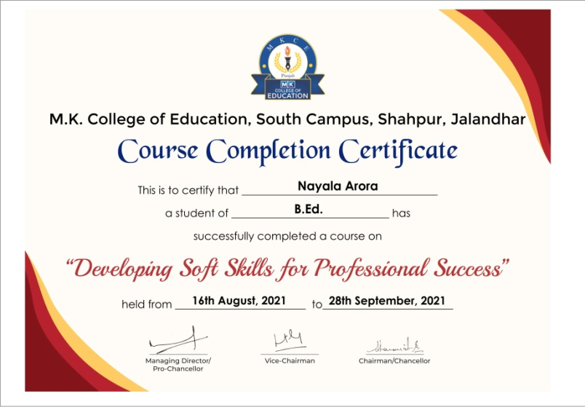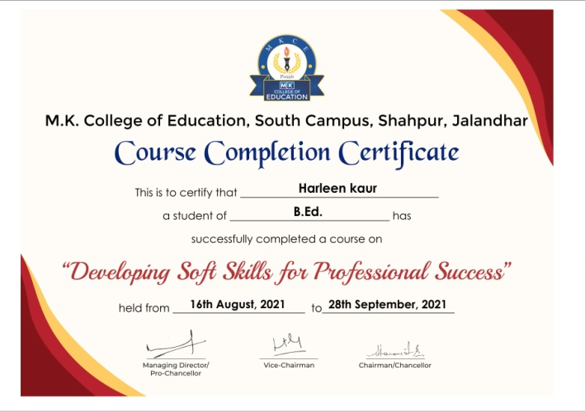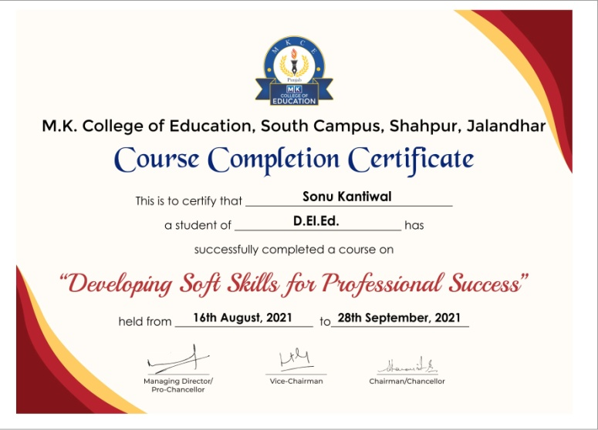

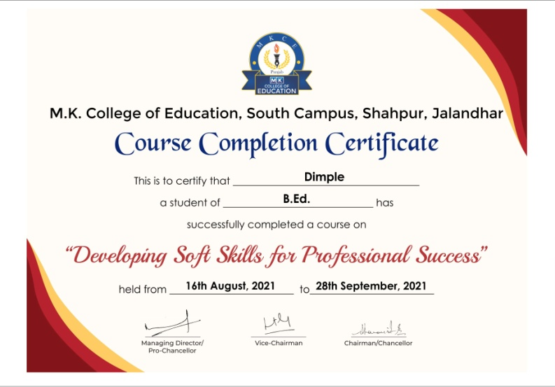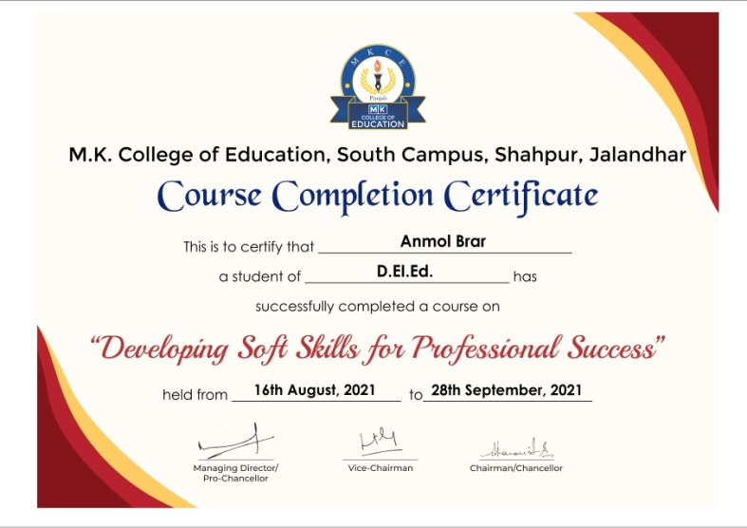

**Feedback from students**

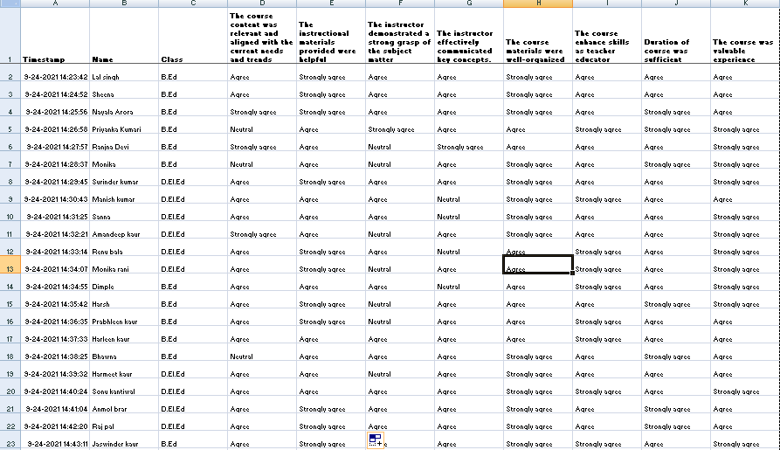

**Date**: 4th October 2021

**Notice**

It is our pleasure to inform all Faculty members and students that M.K. College of Education will be conducting a Value-Added Course on "Pot Painting" Faculty members and students interested in joining the course are requested to contact the course coordinator.

**Course details**

Title: Pot Painting

Duration: 30 Hours

Commencement Date: 11th October 2021

Mode: Online

**Pot Painting**

**Course Duration:** 30 Hours

**Program Learning Outcome**

The course aims to enable the participants to develop a artistic skills in them and helps them to integrate art in teaching learning process.

**Course Learning Outcomes:**

Learners will be able to

1. Explore the history and significance of pot painting.
2. Identify different types of pots and materials used in pot painting.
3. Develop basic skills in preparing pots for painting.
4. Prepare an article of pot painting

**Course Content**

**Unit 1: Introduction to Pot Painting, Color Theory and Mixing (4 hours)**

Overview of Pot Painting, history of Pot Painting, Types of Pots and Materials, Preparing the Surface for Painting, Basics of Color Theory, Color Mixing Techniques, Application of Color in Pot Painting

**Unit 2: Brushwork Techniques and Designs (6 hours)**

Types of Brushes and Their Uses, Brush Strokes and Techniques, Creating Patterns with Brushes, Traditional Pot Painting Designs, Contemporary Trends in Pot Painting, Personalizing Designs

**Unit 3: Texture & Surface Effects and Finishing (5 hours)**

Adding Texture to Pots, Exploring Different Mediums, Creating Depth and Dimension, Finalizing Pot Painting, Sealing Techniques, Troubleshooting and Fixes

**Unit 4: Project (10 hours)**

In-class Pot Painting Project, integrating Final Evaluation and Feedback

**Evaluation Criteria**

At the end of the course, students need to submit one article of pot painting.

**Mode of Classes**

The Course will be conducted through online mode. Google Meet platform will be used to deliver the content.

**Cost**

The course is free of cost

**Important dates**

|  |  |
| --- | --- |
| Registration starts | 5th October 2021 |
| Registration ends | 9th October 2021 |
| Start of Course | 11th October 2021 |
| Final test | 3rd December 2021 |

**Brochure** 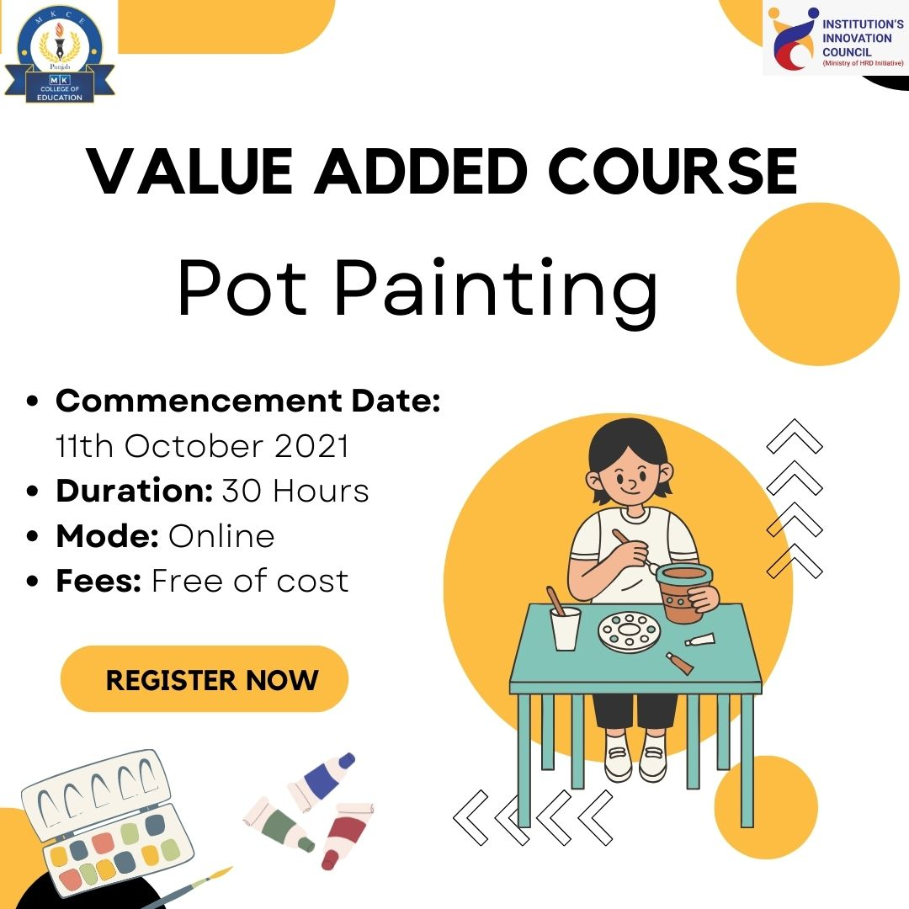

**Classes conducted**

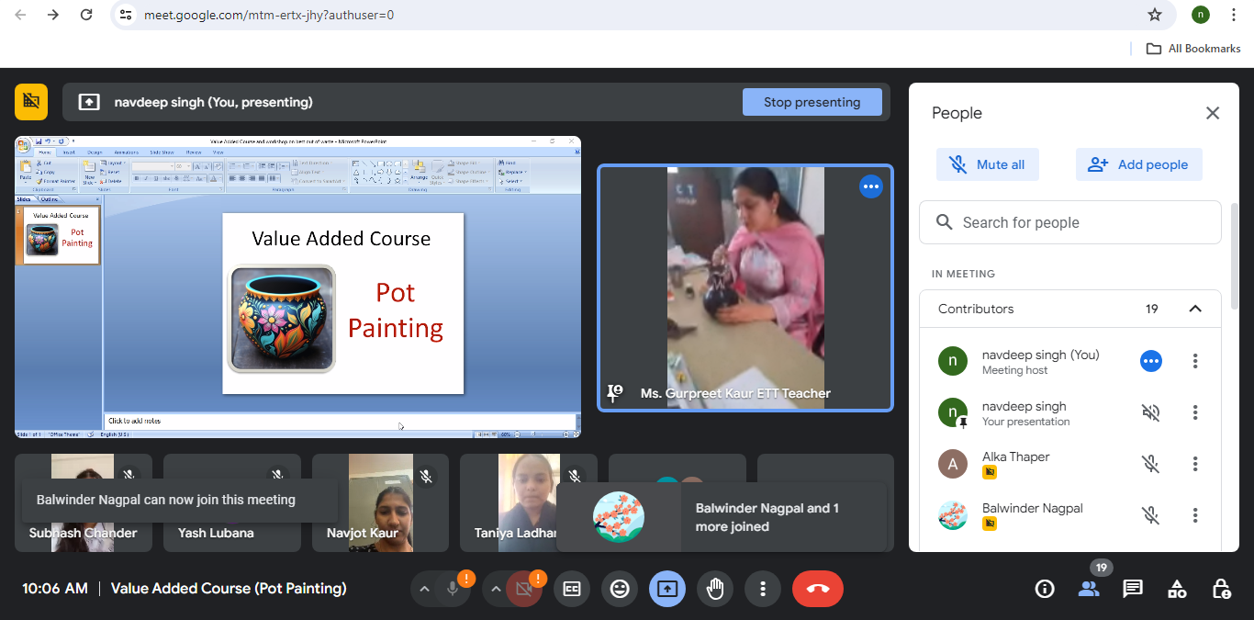

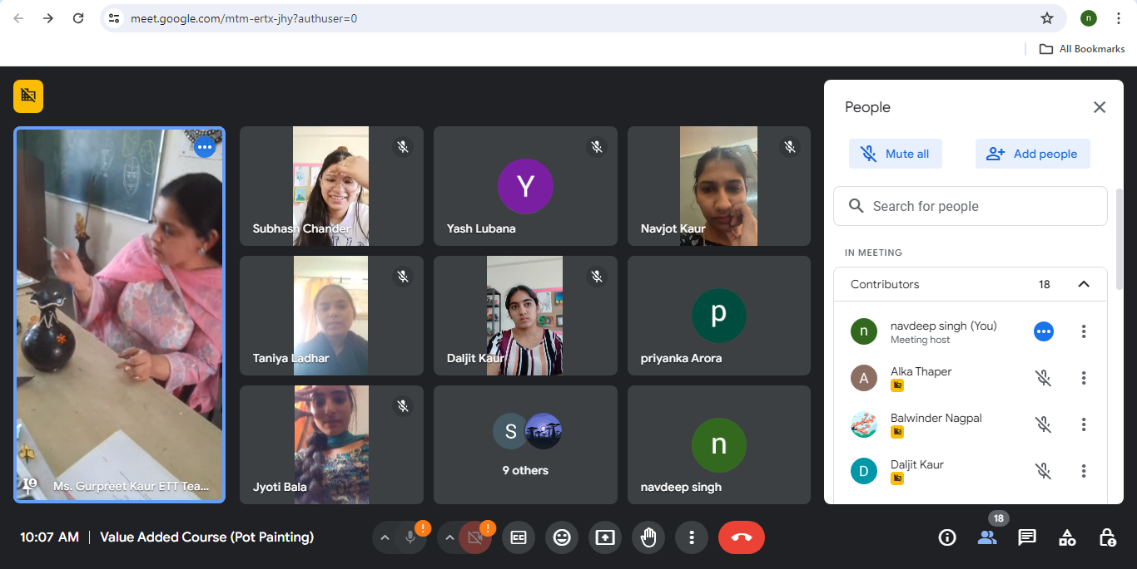

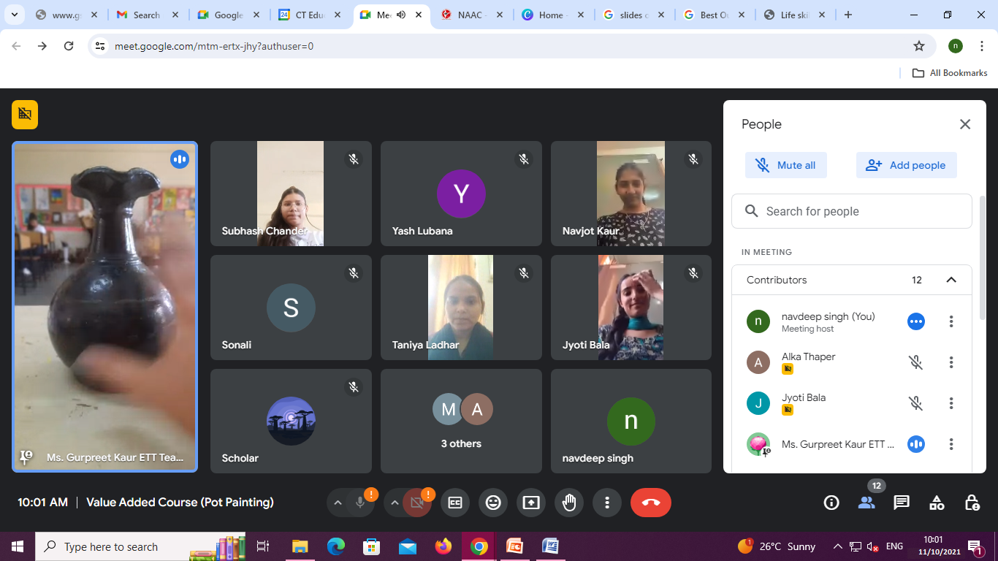

**List of Students enrolled in Value Added Course “Pot Painting”**

|  |  |  |  |
| --- | --- | --- | --- |
| **S.No.** | **Name of the Student** | **Programme** | **Year** |
| 1 | Tania | D.El.Ed. | 2021 |
| 2 | Khushboo | D.El.Ed. | 2021 |
| 3 | Priyanka Chumber | D.El.Ed. | 2021 |
| 4 | Gurpreet Kaur | D.El.Ed. | 2021 |
| 5 | Vishali | D.El.Ed. | 2021 |
| 6 | Simranjit Kaur | D.El.Ed. | 2021 |
| 7 | Daljit Kaur | D.El.Ed. | 2021 |
| 8 | Parminder Singh | D.El.Ed. | 2021 |
| 9 | Anoop Kumar | D.El.Ed. | 2021 |
| 10 | Manisha Kumari | D.El.Ed. | 2021 |
| 11 | Manisha Rani | D.El.Ed. | 2021 |
| 12 | Jyoti Bala | D.El.Ed. | 2021 |
| 13 | Kalpna Rani | D.El.Ed. | 2021 |
| 14 | Subhash Chander | D.El.Ed. | 2021 |
| 15 | Sudhir Kumar | D.El.Ed. | 2021 |
| 16 | Alka Thaper | D.El.Ed. | 2021 |
| 17 | Chander Mohan | D.El.Ed. | 2021 |
| 18 | Kushlya Devi | D.El.Ed. | 2021 |
| 19 | Ravinder Singh | D.El.Ed. | 2021 |
| 20 | Sonali | D.El.Ed. | 2021 |
| 21 | Reena | D.El.Ed. | 2021 |
| 22 | Taniya Ladhar | D.El.Ed. | 2021 |
| 23 | Navjot kaur | B.Ed. | 2021 |
| 24 | Babli | B.Ed. | 2021 |
| 25 | Narinder Kumar Mourya | B.Ed. | 2021 |
| 26 | Onki Choden Bhutia | B.Ed. | 2021 |

**Course completion certificates** 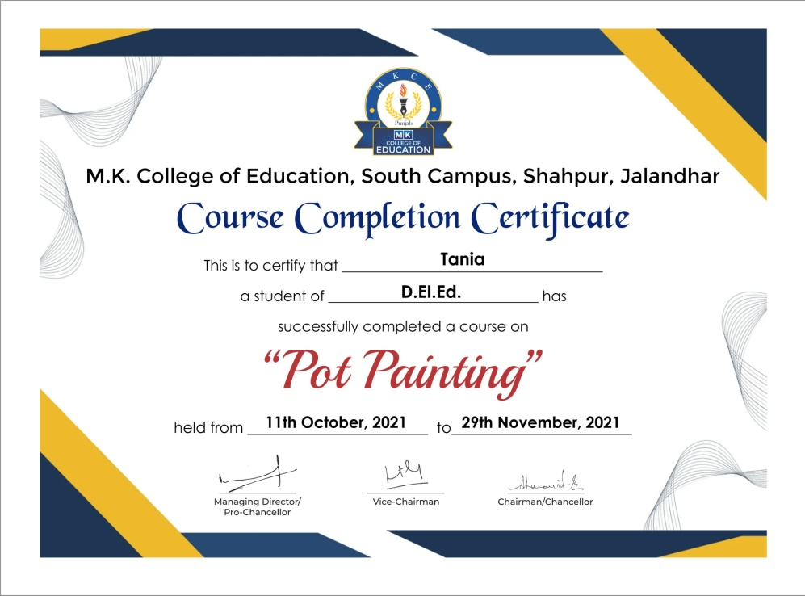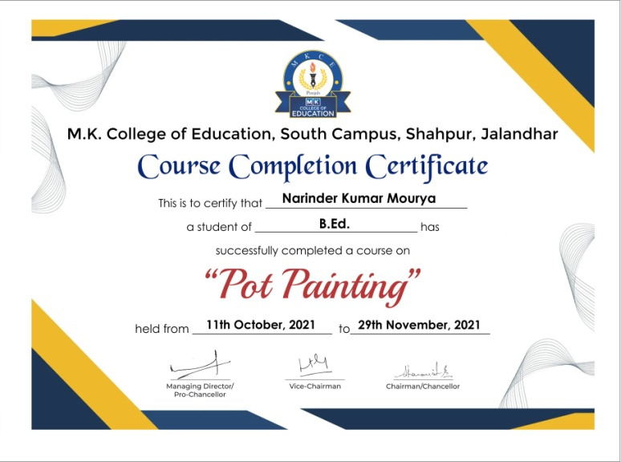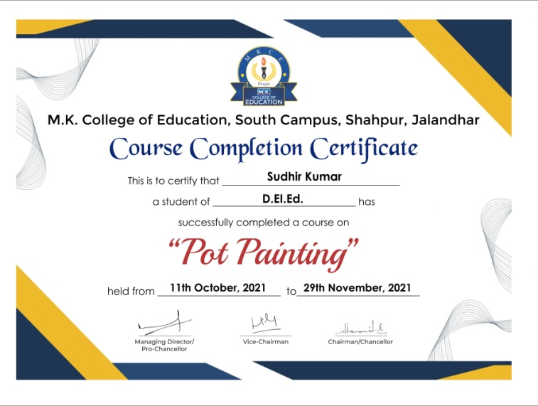

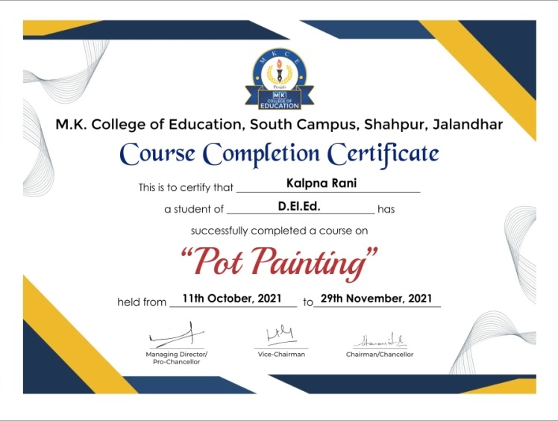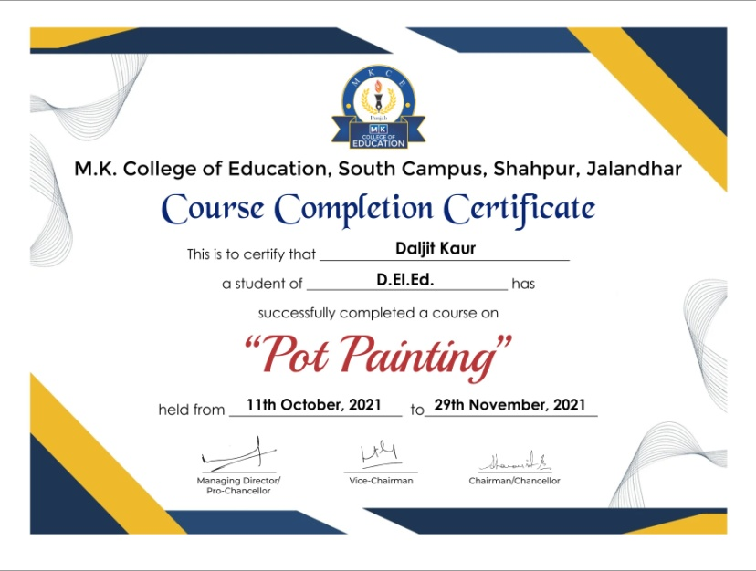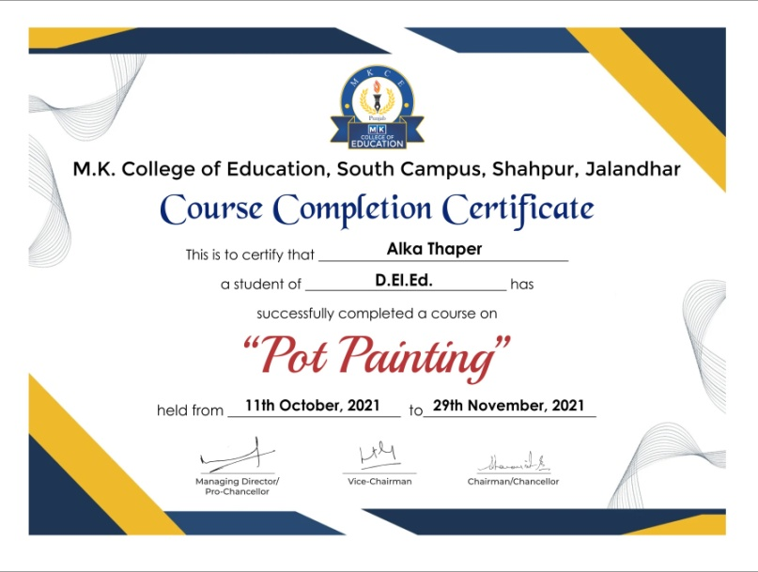

**Feedback from students**

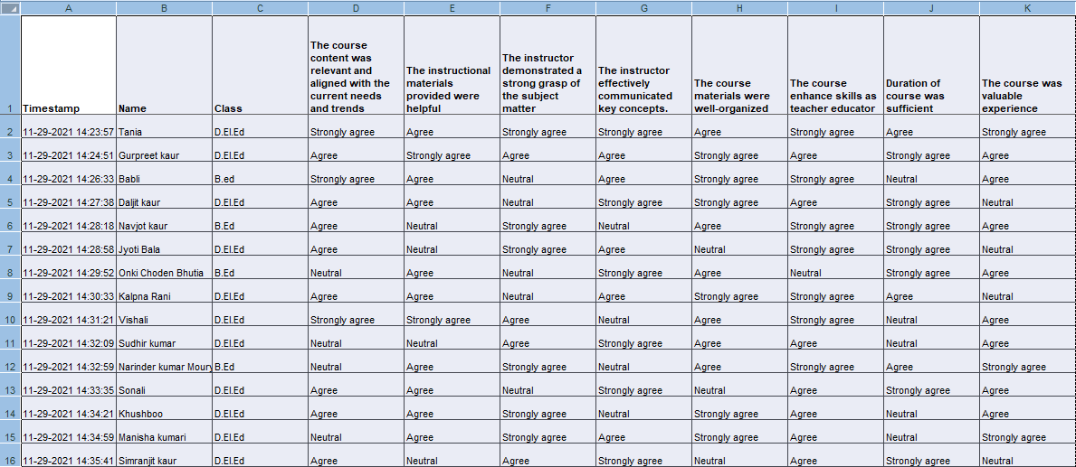

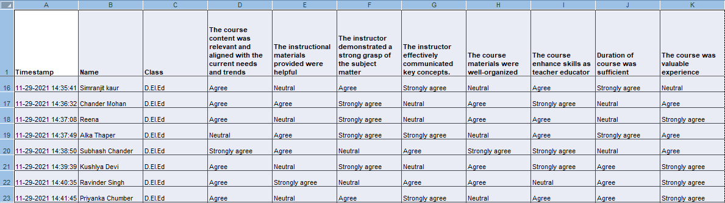

**Date:** 1st January 2022

**Notice**

It is our pleasure to inform all Faculty members and students that M.K. College of Education will be conducting a Value-Added Course on "Life Skills". Faculty members and students interested in joining the course are requested to contact the course coordinator.

**Course details**

Title: Life Skills

Duration: 30 Hours

Commencement Date: 10th January 2022

Mode: Online

**Principal**

Dr. Rajnish Sharma

**Life Skills**

**Course Duration: 30 Hours**

**Program Learning Outcome**

This course is designed to equip participants with essential life skills necessary for personal and professional development.

**Course Learning Outcomes:**

Learners will be able to

1. Explain the concept of life skills
2. Develop and execute modules on thinking skills
3. Prepare and execute modules on coping skills
4. Construct and execute modules on social skills

**Course Content**

**UNIT I Concept of Life Skills (6 Hours)**

Concept, importance of life skills, relevance of life skills in various aspects of life, core components of life skills, life skills approach in education and training

**UNIT II Coping Skills (8 Hours)**

Coping with emotions: orientation, module preparation and execution; coping with stress: orientation, module preparation and execution ; Self-Awareness : orientation, module preparation and execution

**UNIT III Social Skills (8 Hours)**

nurturing relationships: orientation, module preparation and execution; conflict resolution: orientation, module preparation and execution; Communication as a skill for career building module preparation and execution

**UNIT IV Thinking Skills (8 Hours)**

Creative thinking: orientation, module preparation, execution; Problem solving and decision making: orientation, module preparation, execution • goal setting: orientation, module preparation, execution

**Evaluation Criteria**

At the end of the course, a test will be conducted for evaluation. The test will consist of 20 objective type questions carrying 2 marks for each question. It is compulsory to score 40% marks in the final test to earn a certificate of successfully completing the course.

**Mode of Classes**

The Course will be conducted through online mode. Google Meet platform will be used to deliver the content.

**Cost**

The course is free of cost

**Important dates**

|  |  |
| --- | --- |
| Registration starts | 3rd January 2022 |
| Registration ends | 8th January 2022 |
| Start of Course | 10th January 2022 |
| Final test | 3rd March 2022 |

**Brochure**

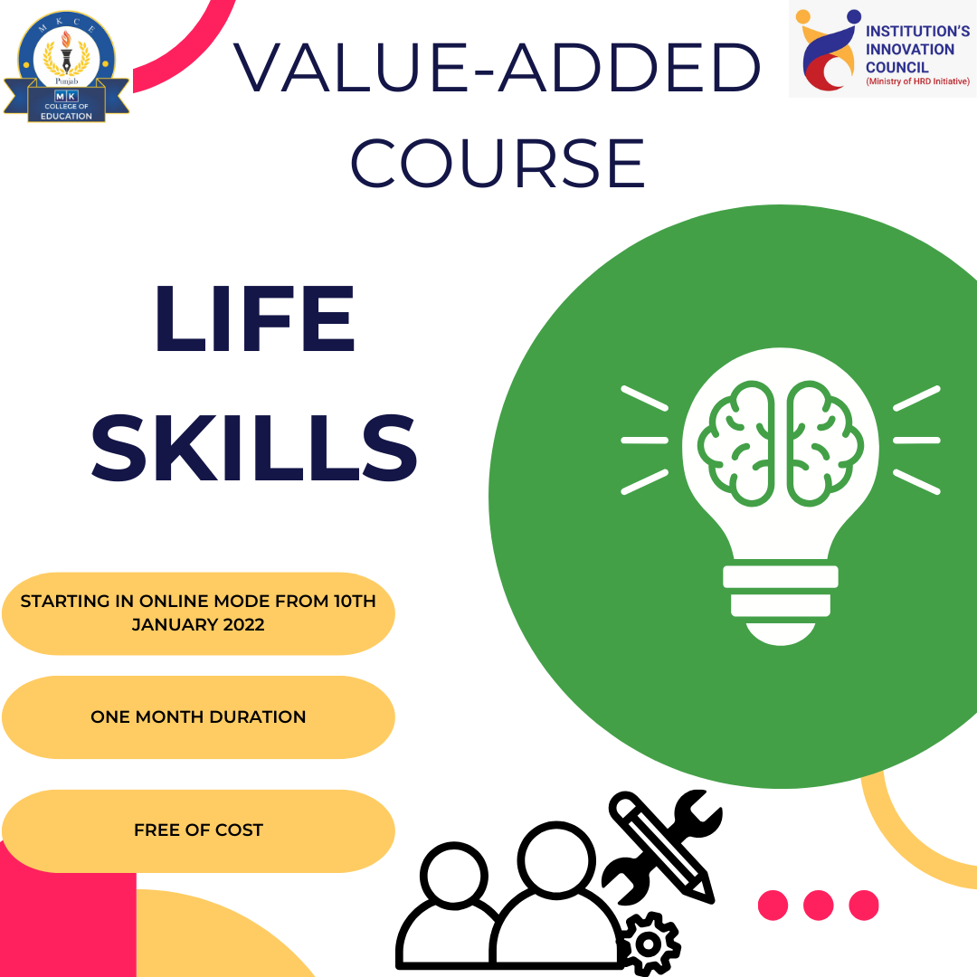

**Classes**

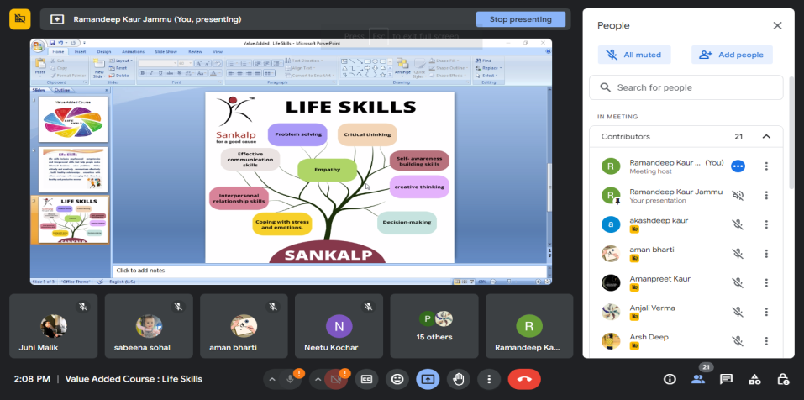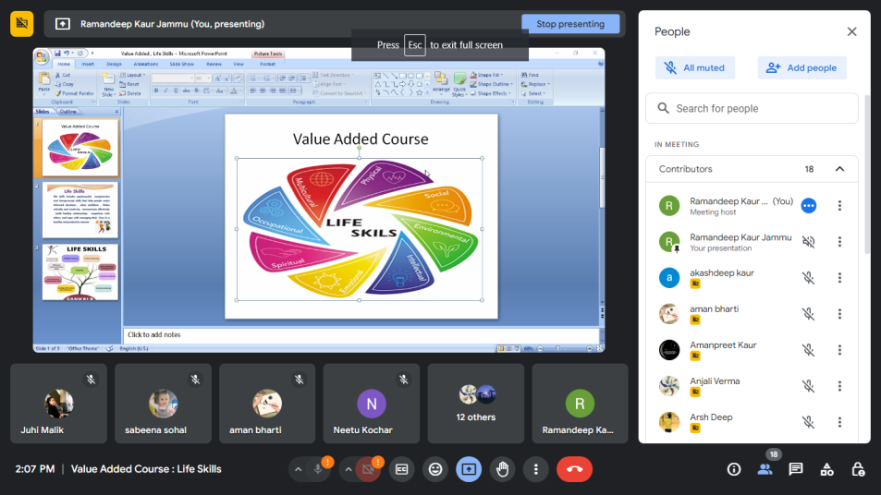 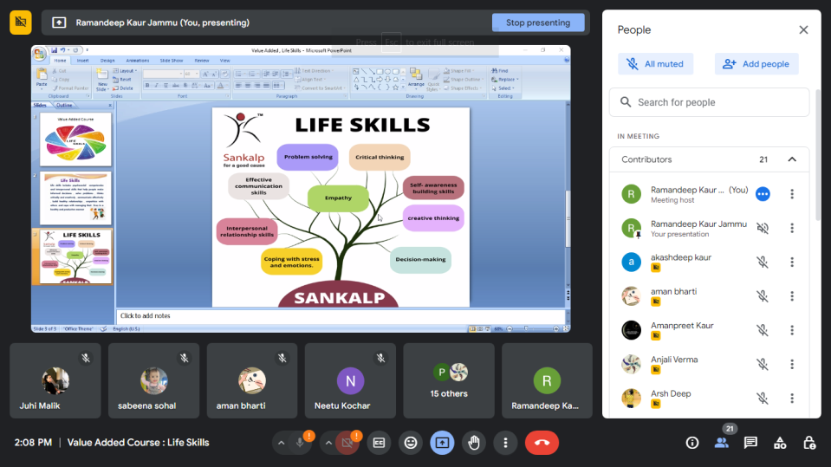

**List of Students enrolled in Value Added Course “Life Skills”**

|  |  |  |  |
| --- | --- | --- | --- |
| **S.No.** | **Name of the Student** | **Programme** | **Year** |
| 1 | Rajni Sharma | B.Ed. | 2022 |
| 2 | Santokh Singh | B.Ed. | 2022 |
| 3 | Parveen Kumari | B.Ed. | 2022 |
| 4 | Bhuvnesh Kumar | B.Ed. | 2022 |
| 5 | Baljinder Singh | B.Ed. | 2022 |
| 6 | Supan | B.Ed. | 2022 |
| 7 | Gurpreet Kaur | B.Ed. | 2022 |
| 8 | Bhanu Priya Sharma | B.Ed. | 2022 |
| 9 | Vasudha Chibber | B.Ed. | 2022 |
| 10 | Sarita | B.Ed. | 2022 |
| 11 | Rajandeep Kaur | B.Ed. | 2022 |
| 12 | Ravi Kiran | B.Ed. | 2022 |
| 13 | Manisha Kumari | B.Ed. | 2022 |
| 14 | Amit Kumar | B.Ed. | 2022 |
| 15 | Dinesh Rai | B.Ed. | 2022 |
| 16 | Renuka Joshi | B.Ed. | 2022 |
| 17 | Jaswinder Kaur | B.Ed. | 2022 |
| 18 | Baljit Kaur | B.Ed. | 2022 |
| 19 | Onki Choden Bhutia | B.Ed. | 2022 |
| 20 | Tanjeet Kaur | B.Ed. | 2022 |
| 21 | Kamini Pathania | B.Ed. | 2022 |
| 22 | Akash | B.Ed. | 2022 |
| 23 | Geeta Rani | D.El.Ed. | 2022 |
| 24 | Ravinder Singh | D.El.Ed. | 2022 |
| 25 | Sonali | D.El.Ed. | 2022 |

**Course Completion certificates**

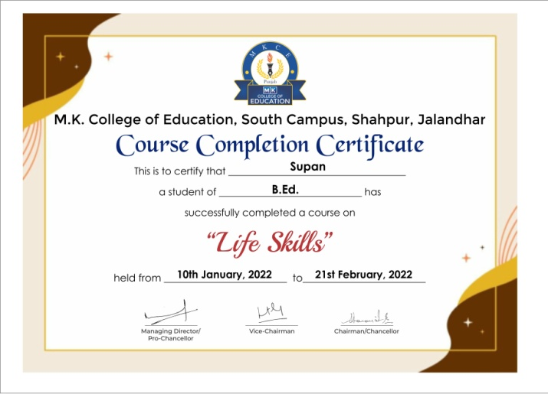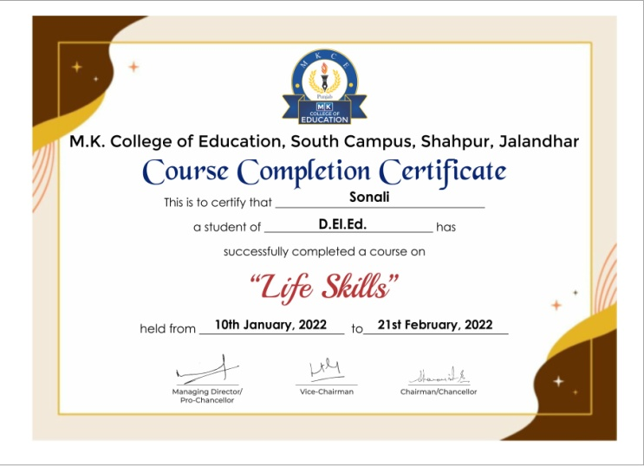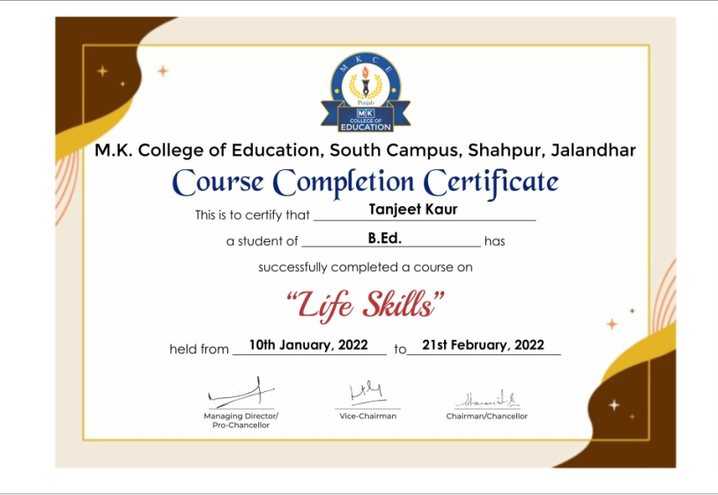

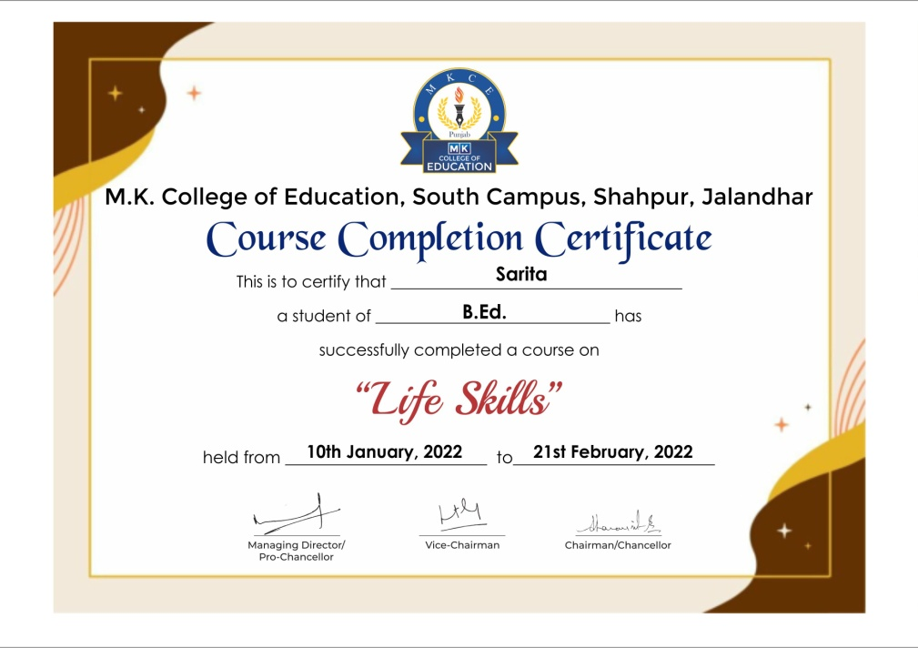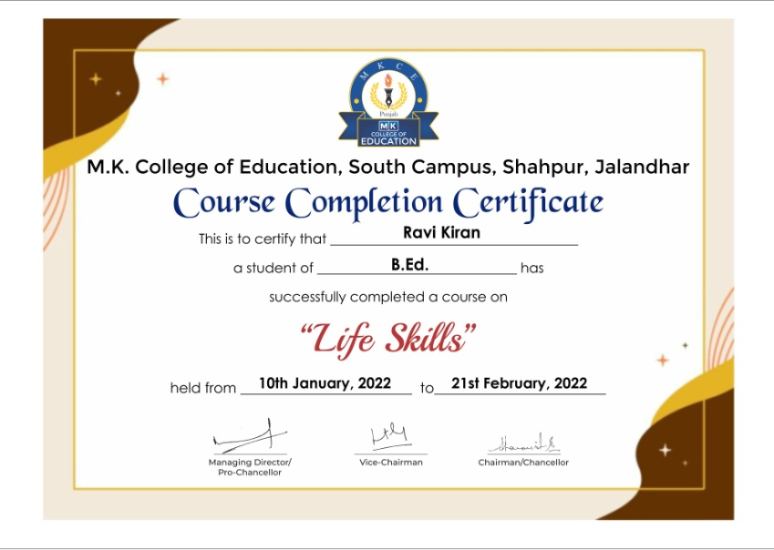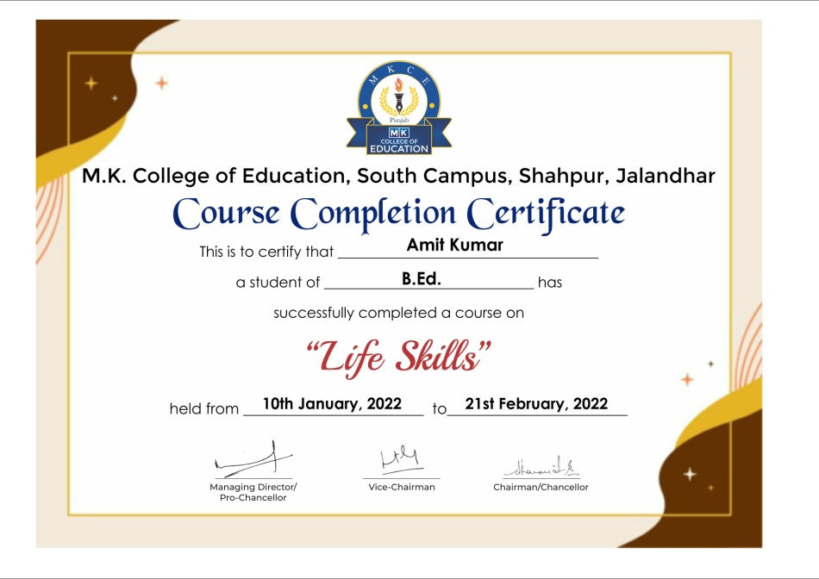

**Feedback from students**

